Week 10
Stack and Dynamic Collections
import java.util.Arrays;
class Solution {
public String[] sortPeople(String[] names, int[] heights) {
int n = names.length;
Integer[] indices = new Integer[n];
for (int i = 0; i < n; i++) {
indices[i] = i;
}
Arrays.sort(indices, (a, b) -> Integer.compare(heights[b], heights[a]));
String[] result = new String[n];
for (int i = 0; i < n; i++) {
result[i] = names[indices[i]];
}
return result;
}
}
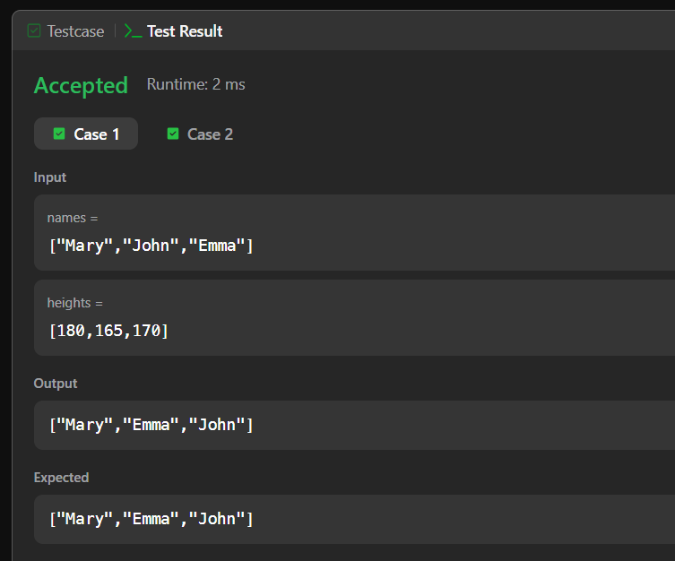

Design Linked List

class MyLinkedList {
private static class Node {
int val;
Node next;
Node(int val) {
this.val = val;
this.next = null;
}
}
private Node head;
private int size;
public MyLinkedList() {
head = null;
size = 0;
}
public int get(int index) {
if (index < 0 || index >= size) {
return -1;
}
Node curr = head;
for (int i = 0; i < index; i++) {
curr = curr.next;
}
return curr.val;
}
public void addAtHead(int val) {
Node newNode = new Node(val);
newNode.next = head;
head = newNode;
size++;
}
public void addAtTail(int val) {
Node newNode = new Node(val);
if (head == null) {
head = newNode;
} else {
Node curr = head;
while (curr.next != null) {
curr = curr.next;
}
curr.next = newNode;
}
size++;
}
public void addAtIndex(int index, int val) {
if (index < 0) {
index = 0;
}

if (index > size) {
return;
}

if (index == 0) {
addAtHead(val);
return;
}
Node curr = head;
for (int i = 0; i < index - 1; i++) {
curr = curr.next;
}
Node newNode = new Node(val);
newNode.next = curr.next;
curr.next = newNode;
size++;
}
public void deleteAtIndex(int index) {
if (index < 0 || index >= size) {
return;
}
if (index == 0) {
head = head.next;
} else {
Node curr = head;
for (int i = 0; i < index - 1; i++) {
curr = curr.next;
}
curr.next = curr.next.next;
}
size--;
}
}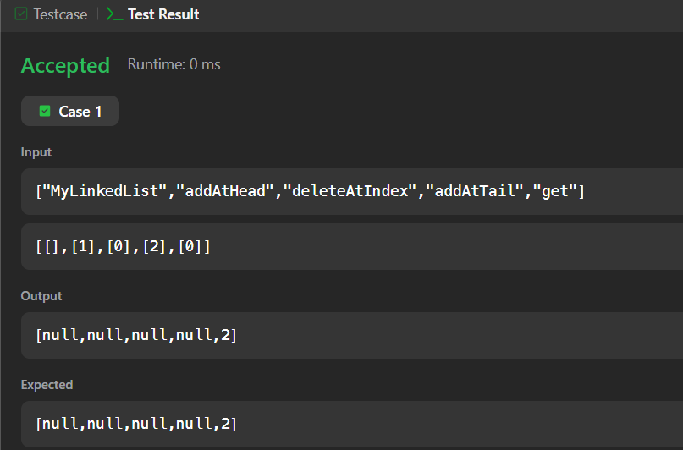
Remove Duplicates from Sorted Array

class Solution {
public int removeDuplicates(int[] nums) {
int k = 1;
for (int i = 1; i < nums.length; i++) {
if (nums[i] != nums[k - 1]) {
nums[k] = nums[i];
k++;
}
}

return k;
}
}
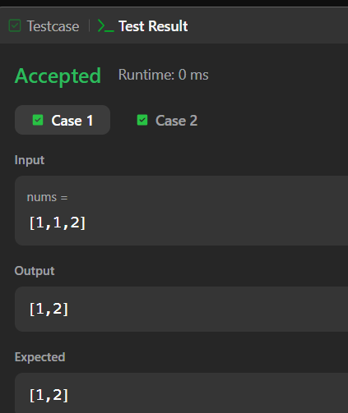
Intersection of Two Arrays

import java.util.HashSet;
import java.util.Set;
class Solution {
public int[] intersection(int[] nums1, int[] nums2) {
Set<Integer> set1 = new HashSet<>();
Set<Integer> result = new HashSet<>();

for (int num : nums1) {
set1.add(num);
}
for (int num : nums2) {
if (set1.contains(num)) {
result.add(num);
}
}
int[] ans = new int[result.size()];
int i = 0;
for (int num : result) {
ans[i++] = num;
}
return ans;
}
}
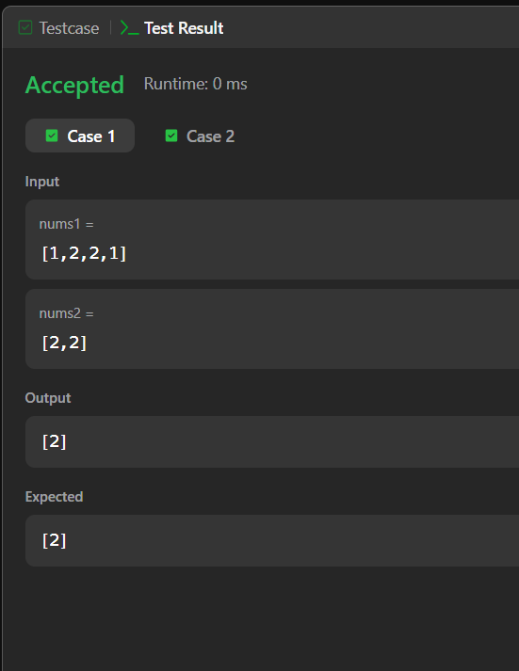
Design HashMap
class MyHashMap {
private static final int SIZE = 1000;
private Node[] buckets;
class Node {
int key;
int value;
Node next;
Node(int key, int value) {
this.key = key;
this.value = value;
this.next = null;
}
}
public MyHashMap() {
buckets = new Node[SIZE];
}
public void put(int key, int value) {
int index = key % SIZE;
Node current = buckets[index];
while (current != null) {
if (current.key == key) {
current.value = value;
return;
}
current = current.next;
}
Node newNode = new Node(key, value);
newNode.next = buckets[index];
buckets[index] = newNode;
}
public int get(int key) {
int index = key % SIZE;
Node current = buckets[index];
while (current != null) {
if (current.key == key) {
return current.value;
}
current = current.next;
}
return -1;
}
public void remove(int key) {
int index = key % SIZE;
Node current = buckets[index];
Node previous = null;
while (current != null) {
if (current.key == key) {
if (previous == null) {
buckets[index] = current.next;
} else {
previous.next = current.next;
}
return;
}
previous = current;
current = current.next;
}
}
}
